**nodeName vs tagName**

**First things first, what is nodeName?**

With nodeName, you can view the name of an element or tag you’re dealing with. You can just console log the nodeName.

Like this for example:

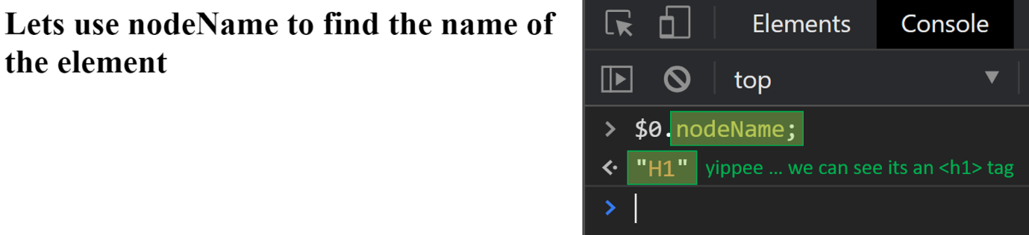

Although there are only a distinct number of node **TYPES**(remember, we covered this in a previous lecture. There are text nodes, comment nodes, element nodes, etc), the node **NAMES**will tell you what element or tag node you’re dealing with. This means that for a <p> element, the nodeName property will return “P”. And for a <div> element, the returned nodeName properly will be “DIV” and so on.

The nodeName is a read-only property of DOM nodes. The returned value is always a CAPITAL string that represents the element type.

As a side note, the nodeName value gives you absolutely no other information (for example you can’t find out any attributes), so its limited in use I guess.

**Hold onto your horses, isn’t this the same thing as the tagName property?**

Kind of.

Another property you can access which will give you the same answer is tagName. And similarly to nodeName , tagName will return the result in CAPITAL letters.

So they look the same, as follows:

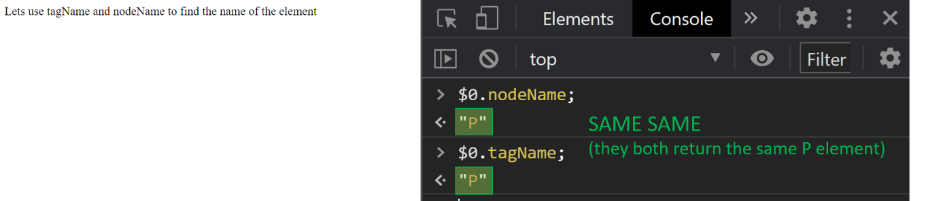

**So Clyde, does this mean nodeName and tagName are the same thing?**

No. They are different.

The tagName property is meant specifically for *element nodes* (remember a few lectures ago, these are TYPE 1 nodes) to get the type of *element*. But as you already know, there are numerous other TYPES of nodes (such as comment nodes, text nodes, etc). To get the name of those nodes you can’t use tagName.

Here is proof that you can’t use tagName on a comment for example:

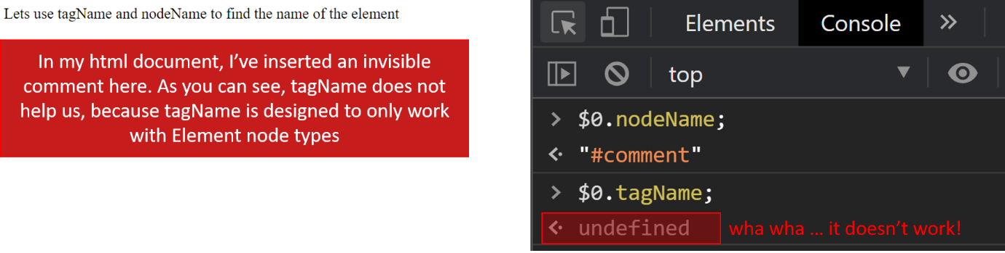

So then, when dealing with Elements, which should you use – nodeName or tagName?

Good question my dear student 😉

It doesn’t really matter I guess. As we’ve just seen, when using nodeName against an *element node*, you'll get its tag name, so either could be used.

However, if a gun were pointed at my head and I had to choose one over the other, I would probably go with nodeName . This will likely give us better consistency across browsers.

Lets march on. I hope you found this useful.